DBMS Assignment Lab 9

Tarun M

PES1UG20CS462

1)

DELIMITER $$  
CREATE TRIGGER max_4_cmpts  
BEFORE INSERT  
ON compartment FOR EACH ROW  
BEGIN  
DECLARE err_msg VARCHAR(255);  
SET err_msg = ('More than 4 compartments are not available');  
IF NEW.availability > 4 THEN  
SIGNAL SQLSTATE '45000'  
SET MESSAGE_TEXT = err_msg;  
END IF;  
END $$  
DELIMITER ;

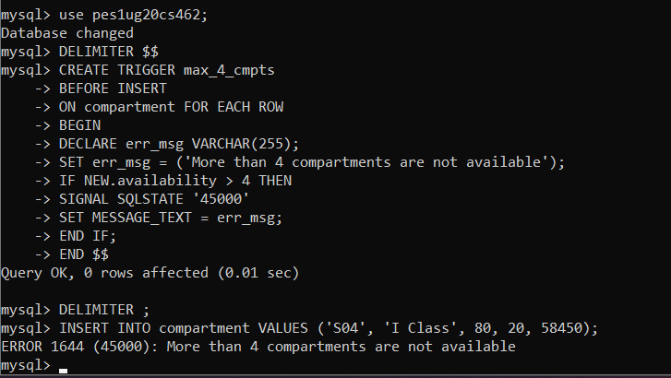

2)

CREATE TABLE backup_transactions(transaction_id INT PRIMARY KEY, bank VARCHAR(20), card_no BIGINT, price DECIMAL(10, 2), pnr VARCHAR(10));

DELIMITER $$  
CREATE TRIGGER backup_transact  
BEFORE DELETE  
ON ticket FOR EACH ROW  
BEGIN  
INSERT into backup_transactions SELECT * FROM payment_info WHERE pnr = OLD.pnr;  
DELETE FROM payment_info WHERE pnr = OLD.pnr;  
DELETE FROM ticket_passenger WHERE pnr = OLD.pnr;  
END;

$$  
DELIMITER ;



